New insights on the application of half-sandwich complexes with metal-iodide bonds for agricultural fungicides.
Maddalena Corsini,¹ Fabrizia Fabrizi de Biani,¹ Antonella Policastro,¹ Nikita V. Shvydkiy, ² Giulia Baini,³ Marco Biagi ^{3,4}

¹ Department of Biotechnology, Chemistry and Pharmacy, University of Siena, via A. Moro 2, Siena, Italy
² Nesmeyanov Institute of Organoelement Compounds, Russian Academy of Sciences, 28 Vavilova Street, Moscow 119991, Russian Federation
³ Department of Physical Science, Earth and Environment, University of Siena, Strada Laterina, 8, Siena, Italy
⁴ Department of Food and Drug, University of Parma, Parma, Italy

Corresponding Author: e-mail: maddalena.corsini@unisi.it

Abstract
Cyclopentadienyl half-sandwich complexes of cobalt and iron with metal-iodide bonds were reported to efficiently inhibit the growth of phytopathogenic fungi. With the aim of investigating the structure/activity relationships, further in vitro experiments were carried out. Cyclic voltammetric characterization, chemical stability and antiradical activity were performed in two solvents: dimethyl sulfoxyde and acetone. The iodide ion removal from the complex and the consequent generation of organometallic fragments appears to be the key-point of antifungal activity. Moreover, a preliminary cell viability test on human keratinocytes was also assessed in order to verify the non-toxic effect of tested compounds. The cytotoxicity for all the complexes was comparable with that shown by povidone iodide, a common antifungal agent recognized as safe (IC₅₀ > 300 mM).
Furthermore, the work propones an additional roadmap (sequence of experiments) at the initial antifungal activity tests, that improves insight into their mechanism of action.

Keywords: antifungal agent, organometallic, iodine, antioxidants, cyclic voltammetry

1. Introduction
There are approximately 144,000 different species of fungi on the Earth, including molds, yeasts and mushrooms. Fungi can be found in many different habitats, including rocks, lakes, seas, as well as on organic matter, including other organisms, such as plants, animals, and even human body. [1] Fungi are essential in many industrial and food processes and recently, some fungal strains (for example Fusarium, Aspergillus, Verticillium and Pencillium spp.) have been proposed as bionanofactory resources for synthesis of nanoparticles (myconanoparticle). [2], [3]
At the same time, fungi are also pathogens of plants, animals and human and are causative agents for many diseases. [4] In agriculture, fungi cause crop losses worldwide with a considerable economic impact on plant yield. Managing such diseases is a crucial key of most crops’ production and it requires a careful chemical control especially in the use of fungicides.
Agricultural fungicides are compounds that specifically inhibits or kills one or more fungi species and they are classified according to their biochemical mode of action (MoA). As described for bacteria, also fungi rapidly develop resistance to one fungicide and simultaneously become resistant to those other fungicides that have the same MoA or the same target-site. [5] The management strategy proposed to overcome the problem of fungicide resistance include the use the combination of compounds with different MoA and/or the rotation of different fungicides during the crop growing season. [6] From these basic principles of fungicide resistance management, emerges the need for new and innovative fungicides and the development of new solutions is the challenge for the agrochemical industry.
Some inorganic salts were tested for their effectiveness as agricultural antifungal agents [7] and their MoA is related to intracellular pH and redox status modification and fungus respiratory chain impairment. Besides, metal complexes offer potentially advantageous properties because their ability to access multiple different and unique modes of actions, for example redox reactions, generation of reactive oxygen species, ligand exchange etc. At the best of our knowledge, very few inorganic complexes have been trailed. [8] Herein, we report a multidisciplinary approach aim to understanding the structure-function relationship of some cyclopentadienyl half-sandwich complexes of cobalt and iron with metal-iodide bonds and their fungicide activity.

2. Results and discussion

Some years ago, D.A. Loginov et al. tested the phytopatogenic antifungal properties of some iron- and cobalt- half-sandwich complexes (1, 3, 6 in Scheme 1) correlating such properties to the presence of metal-iodine bond(s). [9] The panel of complexes used in that work was expanded to others which antifungal test was not reported (2, 4, 5 in Scheme 1). With the aim to understand the possible mechanism of action, the redox and antiradical properties were performed in two solvents: acetone and dimethyl sulfoxide (DMSO).

Scheme 1. Tested compounds

Moreover, in a practical translational perspective, since the exposure of consumers and workers to fungicides through contact might threaten human health in the long term, then test on human keratinocytes was performed to evaluate their cutaneous safety.

2.1 Cyclic Voltammetry
It is known that iodine can rapidly penetrate the cell wall of microorganisms and exerts its lethal effect as disruption of protein and nucleic acid structure and synthesis. Its toxicity in fact, is correlated to its strong oxidizing effects on the functional groups of amino acids and fatty acids. This mechanism is invoked to explain antifungal activity of iodine.
The I⁻/I₂ redox process has been extensively studied in various solvents and the overall process is described by the following EC-type scheme:
E: I⁻ is oxidised to I₂
2I⁻ ⇋ I₂ + 2e⁻ eq. (1)
C: Iodide is a Lewis base and iodine is a Lewis acid that can combine to form triiodide anion
I₂ + I⁻ ⇋ I₃⁻ eq. (2)
Is evident that the driving force for the formation of polyhalogenated complex is correlated with the donor-acceptor interactions with the solvent and by the equilibrium constant (K_{stab}) of reaction in eq. 2. In some conditions (large K_{stab} and/or high bulk concentration of I⁻/I₂) the formation of I₃⁻ is favored, then reaction in eq. 1 occurs in two separated steps:

3I⁻ ⇋ I₃⁻ + 2e⁻ eq. (3)
I₃⁻ ⇋ 3/2I₂ + e⁻ eq. (4)
In the close proximity of the positively polarized working electrode, while I⁻ is depleted the local concentration of I₃⁻ increases, and then I₂ becomes the final oxidized species. In this case, all species participating in the electroxidation reaction are soluble in the organic solvents therefore, well-defined voltammograms are obtained. [10]
In order to recognize oxidation processes of the iodide, cyclic voltammetric study of NBu₄I and povidone-iodine (PVP-I) were performed. PVP-I is a popular antiseptic constitutes by a biocompatible polymer with very good iodophor property, and elemental iodine. [11] In DMSO solution, PVP-I showed a principal irreversible oxidation at potential value E_{pa} =+1.10 V. After cathodic scan, a new irreversible oxidation peak appeared at +0.51 V (Fig. S1). By comparing the peak potential value with that recorded for NBu₄I in DMSO (+0.47 V, Fig. S2), reasonably they could be attributed at iodide oxidation.
The redox properties of metal complexes were investigated both in acetone that DMSO as suitable dissolution solvents: acetone because was used for antifungal activity valuation, while DMSO was chosen because its exceptional solvent properties and its high water miscibility.
The monomers 1 and 2, show two reduction processes both in DMSO and acetone solution. In Figure 1 are illustrated the cyclic voltammograms of the complex 1 in DMSO in two different directions of scan. The process indicated as A is chemically irreversible, while the other one, indicated as B, is electrochemically quasireversible (ΔE = 157 mV) and partially chemically reversible, as given by the ratio i_{pb}/i_{pf} ≃ 0.5.
This redox behavior was deeply discussed by Munisamy at al. [12] The iodide metal complex, MI (where M = [CpFe(CO)₂]), underwent a reduction to form the corresponding anion complex [MI]⁻ in corresponding of peak A. This latter is a 19-electron metal complex that rapidly evolves to the neutral complex M releasing iodide resulting an irreversible process. Subsequently, the complex M underwent to a reduction resulting in the monoanion M⁻ at potential values near the first reduction A. As reported, at inert electrode the products of the reduction of [MI]⁻ can be M, which may be further reduced to M⁻, or it can dimerize to M₂. The dimer M₂ underwent to the reduction step indicated with B in Figure 1. This attribution could be confirmed by comparing peak potential value of the more cathodic dimers’ reduction with those of monomers (peak B, Table 1).
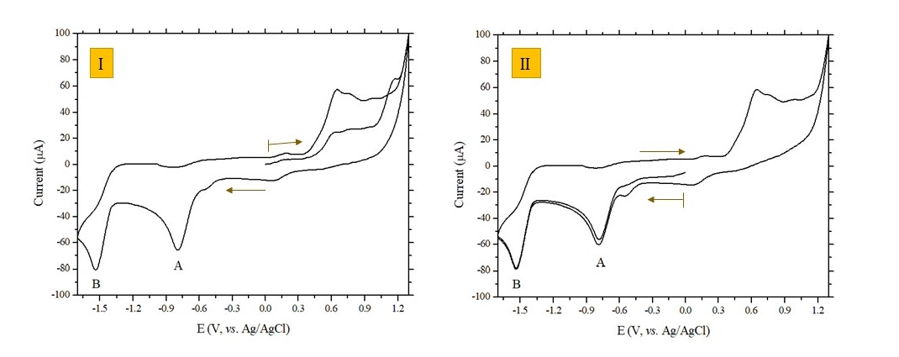
FIGURE 1. Cyclic voltammograms of 1 (1x10⁻³M) in two different directions of scanning of potential, (I) in positive-going scan and (II) in negative-going scan, recorded in DMSO solution using glassy carbon as working electrode. Scan rate: 200 mV/s. Supporting electrolyte: TBAPF₆ 0.1 M

The pentamethylated complex 2 showed a similar redox pattern compared to 1, but peak potential values were cathodically shifted. It is due to the inductive effects of alkyl substituents, in fact the pentamethylcyclopentadienyl ligand is a better donor than the cyclopentadienyl group.
TABLE 1

Table 1. Electrode potential values (V, vs. Ag/AgCl) and peak-to-peak separation (mV) recorded for the iron-complexes ( 1 x 10⁻³ M ) in DMSO and acetone (italic) solution. Scan rate: 200 mV/s
 | Oxidation |  |  | Reduction
Sample |  | E_{p} ª | E°’ (ΔE) | E_{pA} ª | E°’_{B} (ΔE) | Solvent
CpFe(CO)₂I (1) |  |  | +1.20ª  +1.26 (176) | -0.79  -0.94 | -1.45 (157)  -1.56 (182) | DMSO  Acetone
Cp*Fe(CO)₂I (2) |  |  | +1.03ª  +1.10 (106) | -0.87  -1.13^{b} | -1.70 (152)  Not recorded | DMSO  Acetone
[Cp*Fe(CO)₂]₂ (5) |  | +1.20  +1.10 | +0.44  +0.46 (45) | -0.72ª  -1.73ª | -1.73(133)  -1.95 | DMSO  Acetone
[CpFe(CO)₂]₂ |  | - | - | - | -2.26^{c} | CH₃CN
Ferrocene |  |  | +0.51 (69)  +0.46 (102) |  |  | DMSO  Acetone
ª Peak potential values; ^{b} From DPV ^{c} (V, vs Fc⁺/Fc) [12]

The positive region of cyclic voltammogram showed a complicated profile as consequence of proximity of iodide and iron fragments oxidation processes. However, in DMSO solution the chemically irreversible process at E_{pa}= +1.20 and +1.03 V for 1 and 2 respectively, were reasonable to attribute to the metal oxidation Fe(II)/Fe(III). In fact, in the weakly coordinating solvent acetone, these processes became chemically reversible and their peak currents were similar to that of an equimolar ferrocene mono-electronic oxidation process (Fig. S3).
The (η⁴-C₄H₄)Co fragment was isolobal with CpFe leading to a close relationship between the chemistries of these two fragments. Both underwent electrophilic substitution and numerous derivatives containing the CbCo fragment are known. [13] Given the close relationship between CbCo and CpFe we decided to investigate the redox activity of a dyad which contained both isolobal partners, namely 2 and 4. While for the complex 2 was reported an antifungal activity, but no data are known for complex 4.
The cobalt complex 4 was sufficiently stable in DMSO and it was possible to record cyclic voltammograms repeatable at least just for one hour after dissolution (Fig. 2).

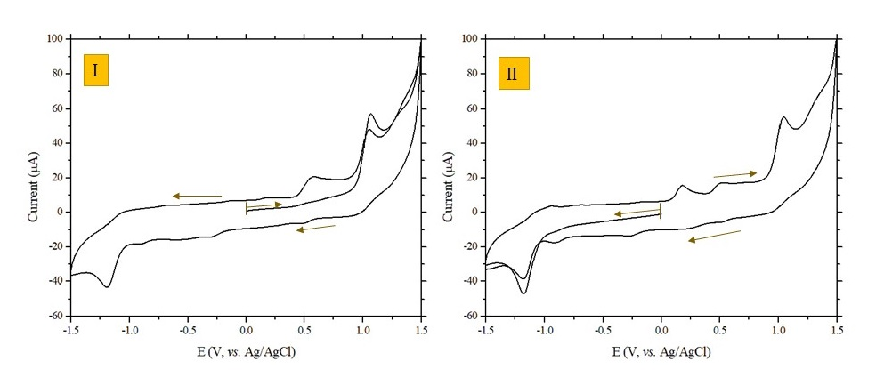
FIGURE 2. Cyclic voltammograms of 4 (1.0 x 10⁻³ M) in DMSO solution recorded in two different directions of scanning of potential, (I) in positive-going scan and (II) in negative-going scan. Scan rate: 200 mV/s. Supporting electrolyte: TBAPF₆ 0.1 M

The complex [Cb*Co(CO)₂I] underwent an irreversible reduction at E_{pc} = -1.20 V followed by an anodic peak at E_{pa} = +0.51 V in the back scan, that is reasonably due to iodide released by complex 4.
In DMSO, the cobalt complexes 3 and 6 react in a few minutes and the time scale of cyclic voltammetric characterization not competes with the time scale of the chemical steps. For this reason, on the freshly prepared solution of 3, only a single voltammogram (Fig. 3a) was recorded. Only few information can be used to describe the redox properties of this complex. Briefly, a more cathodic reduction wave occurs at E_{pc} = -0.33 V and a second one at E°’= -1.87 V (ΔE = 126 mV). As consequence of the reduction scan an irreversible peak appears ( E_{pa} = +0.22 V), probably centered on the cobalt fragment electrogenerated during negative potential scan, and a couple of oxidation processes at more anodic potential could be attributed to iodide.
After some minutes, the cyclic voltammogram evolved to that shown in Fig. 3b. Moreover, peaks attributed to iodide were present at the potential value above +0.5 V. Substantially, the substitution of DMSO molecules to iodide and carbonyl substituents determinates more accessible reduction states.
The DMSO solution of dimer 6 changed color after few second after dissolution and the cyclic voltammogram was comparable to Figure 3b.
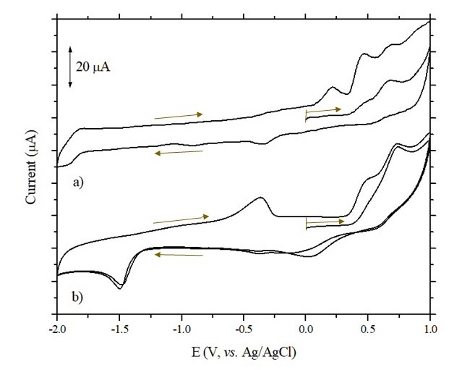
FIGURE 3. Cyclic voltammograms of 3 in DMSO solution (1.0 x10⁻³ M) (a) on the freshly prepared solution and (b) after a few minutes from dissolution. Scan rate of 200 mV/s.

Also in acetone solution, the complex 3 and the dimer 6 evolve too quickly for cyclic voltammetry time scale. In general, they showed an initial irreversible reduction process (at around -0.2 V) that disappeared after one-two minutes. Also in this solvent, complex 4, [Cb*Co(CO)₂I], showed a relatively higher chemical stability than that the other cobalt complexes, that allowed to recorded repeatable cyclic voltammograms almost in the first five minutes from dissolution. It underwent two irreversible oxidation processes that could be due to the oxidation of metal and of the iodide, while the nature of the cathodic process will be further investigated (Fig. S4).
What observed is in accordance with expected. In fact, all these complexes are in a pseudo-octahedral coordination surrounding, thus the d orbitals are split in two set: a non-bonding (“t2g”) and an antibonding (“eg”) one. Thus, d⁵/d⁶ Fe (II/III) only occupy the non-bonding set of orbitals, while the reduction of d⁶ Co(III) to d⁷ Co(II) forces the occupation of the antibonding set of orbitals and costs a great amount of energy, also prompting a severe distortion. This is in summary the main reason of the difference between the redox propensity and the different stability of Fe/Co complexes.

2.2 Stability in DMSO
As discussed in paragraph 2.1, cobalt complexes 3 and 6 were unstable in DMSO, and then UV-Vis and ¹H-NMR spectra were collected over a period of 2-3 hours, to verify their chemical stability.
UV-Vis spectrum recorded on the solution of complex 3 showed a visible band at 622 nm that starts to decrease immediately after dissolution (Fig. S5) while the dimer 6, [Cp*CoI₂]₂, faster gives reactions and it was impossible acquire a satisfactory UV-Vis spectrum.
Instead, the UV-Vis spectra recorded on the solution containing complex 4 , [Cb*Co(CO)₂I], showed a main absorption at 435 nm during the first 3 hours from dissolution. It confirms the higher chemical stability of complex 4 than that 3 and 6.
¹H-NMR analysis in DMSO-d₆ solution of cobalt complexes was performed too. Dark red-violet solution of 3 in DMSO-d₆ gradually turns to orange-yellow. In the spectrum there are signals of starting complex (δ = 2.10 ppm) as well as signals of decomposition products (Fig. S6). It was shown that reactions of 3 with coordinating solvents such as dimethyl sulfoxide or water can lead to the CO, halogen and even cyclopentadienyl replacement. These observations correlate with previously reported dissociation of cyclopentadienyl cobalt complexes in polar media. [14], [15], [16] Accordingly, the cobalt dimer 6 rapidly degrade in DMSO solution.
In contrast, all the iron complexes showed stability over a period of 3 hours in DMSO solution.
To conclude, two factors facilitate the contribute to iodide release: i) metal reduction and ii) solvolysis reactions.

2.3 Antiradical activity
The redox activity and antiradical capacity have been often taken into account to elucidate the molecular mechanism of some antifungal compounds; the correlation between antiradical and antifungal activity or redox activity, have been yet reported, in particular for some natural compounds. [17], [18] In this work, for this reason we also evaluated the antiradical capacity of metal-iodine complexes through the validated spectrophotometer DPPH (2,2-diphenyl-1-picrylhidrazyl) test.
Solvent very affected the antiradical activity of tested sample in most cases and in acetone antiradical capacity was higher than in DMSO. Five out of six tested compounds showed a detectable antiradical activity, solvent and concentration-dependent. At 1000 mg/L the intense color of DPPH:sample solution did not lead us to record unambiguous data of DPPH radical inhibition, even if at this concentration all complexes showed the highest activity.
At 200 and 100 mg/L, the tested iron complexes exerted higher antiradical capacity compared to cobalt complexes (Fig. 4). It could be reasonably related to a more accessible redox processes The relationship between antiradical activity, redox properties and chemical stability can be highlighted recalling that the DPPH test is based on a redox reaction where the substrate (A) undergoes oxidation and DPPH• reduction:
DPPH• + A → DPPH + A•
Subsequently, the antiradical activity is related to the oxidation accessibility of the different compounds, to their stability in different solvents (that may change the chemical structure), but also to the electrode potential of DPPH• (E_{DPPH}) that depends on experimental conditions and used solvent as well. In the conditions set for this work, iron complex 5 in acetone exerted the highest antiradical activity being the compound with the lowest E°’ in the solvent where the stability is maximum.
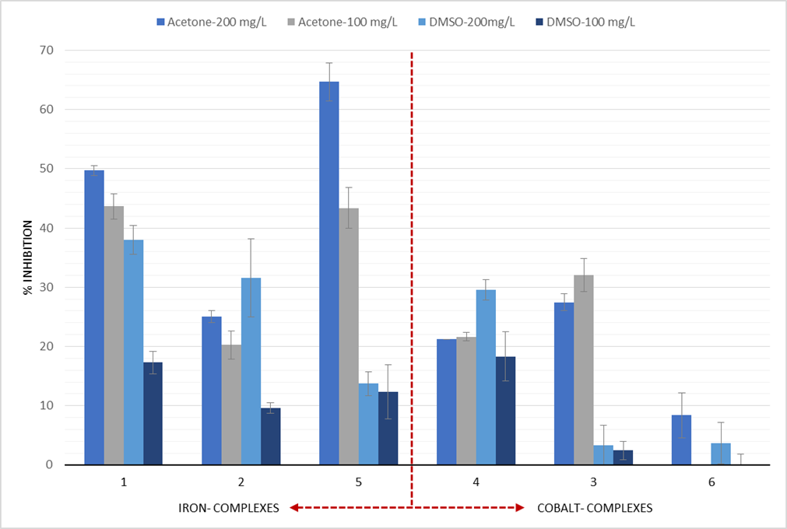
FIGURE 4. Bar chart show average activity and relative standard deviation of antiradical activity at different concentrations of samples in both DMSO and acetone solvents.

2.4 Citotoxicity
Since these compounds could be developed as suitable antifungal drugs for human health and for agricultural applications, we decided to test their cutaneous safety. In order to do that, the test was performed on human keratinocytes, epidermis cells.
All the complexes had a very high IC₅₀ (inhibitory concentration for the 50% of cell viability, Table S1), that in 5 cases out of 7 was equal or similar to that of PVP-I, here tested also as a reference marketed drug, already recognized as safe.

3. Conclusions
The use of a mix of antifungals with different MoA is encouraged to overcome the resistance problems, therefore, accurate investigation on the mode of action of a potential fungicide represents a crucial activity. [18] In the past, some metal iodide half sandwich complexes were reported as potential antifungal agents and, in this work, we propose some insights in the investigation of their MoA.
Chemical stability and redox characterization were performed in DMSO and acetone solution. In general, the iron complexes showed a higher stability and a richer redox aptitude which could be correlated with a higher antiradical activity. Instead, when cobalt complexes dissolved in the solvents, solvolysis reactions occur which lead to a quick iodide release. Among the cobalt derivatives, [Cb*Co(CO)₂I] containing the CpFe isolobal fragment Cb*Co, showed intermediate properties between iron- and cobalt-cyclopentadienyl half sandwich complexes and therefore, it deserves further consideration.
Besides, it is possible to speculate that the antifungal activity reported for this group of complexes could be due to the easy iodide ion removal from the complex and the consequent generation of organometallic fragments. These resulting organometallic complexes are very reactive species Furthermore, it is conceivable that the observed antifungal activity of this class of complexes originates from the easy removal of iodide ions and the consequent formation of organometallic fragments, that may be the units possessing the observed antifungal property. Indeed, as confirmed by multiple studies, [] organometallic complexes could be involved in redox reactions with generation of reactive free radicals (i.e. reactive oxygen species or reactive nitrogen species) that lead biological systems to oxidative stress. Furthermore, other organometallic complexes, with different metal-halide bonds (different from iodide), lack any antifungal effect [9].
Therefore, they could induce (redox) reactions that lead biological systems to oxidative stress.
Moreover, a preliminary investigation on the safety of their potential use by farmers/workers and all the complexes have showed a very low cytotoxic impact on human keratinocytes, equal or similar to that of povidone-iodide.
With this work, we want to stress fascinating challenge represented by the introduction of redox active organometallic complexes in the “pesticides basket”. With the ambition of achieving a synergistic effect, possible through multiple combinations of metal ions and antifungal agent ligands, the half-sandwich complexes with iodide ligand could be consider as lead compounds in the development of new antifungal drugs. Indeed, with the ambition of achieving an ameliorative effect, possible through multiple combinations of reactive metal ions and antifungal agent ligands, the half-sandwich complexes with iodide ligand could be considered as interesting lead compounds in the development of new antifungal drugs being non-cytotoxic and effective candidates to be developed for their optimization in targeting different pathogens.

4. Materials and methods
4.1 General
Iron and cobalt complexes CpFe(CO)₂I, [23] [Cp*Fe(CO)₂I, [24] [Cp*Fe(CO)₂]₂, [25] Cp*Co(CO)I₂, [26] [Cp*CoI₂]₂, [27] and (C₄Me₄)Co(CO)₂I, [28] were synthesized according to the literature procedures. NMR spectra were measured with a Bruker Avance 400 spectrometer at 20 °C. Chemical shifts are reported in ppm using the residual signals of the solvents as internal standards.
CpFe(CO)₂I (1)
¹H NMR (CDCl₃, 400 MHz) δ: 5.04 (s, 5H, Cp). ¹³C NMR (CDCl₃, 101 MHz) δ: 212.89, 84.32. [29]
Cp*Fe(CO)₂I (2)
¹H NMR (C₆D₆, 400 MHz) δ: 1.49 (s, 15H, Cp*). ¹³C NMR (C₆D₆, 101 MHz) δ: 216.52, 95.79, 10.18. [30]
Cp*Co(CO)I₂ (3)
¹H NMR (400 MHz, CDCl₃) δ: 2.23 (s, 15H, Cp*). ¹³C NMR (CDCl₃, 101 MHz) δ: 101.2, 11.61. [23] please note, that signals of CO signals are not picked up after 20 minutes of NMR experiment
(C₄Me₄)Co(CO)₂I (4)
¹H NMR (400 MHz, (CD₃)₂CO) δ: 1.91 (s, 12H, Cb*). ¹³C NMR ((CD₃)₂CO, 101 MHz) δ: 94.53, 10.14. [28] please note, that signals of CO signals are not picked up after 20 minutes of NMR experiment
[Cp*Fe(CO)₂]₂ (5)
¹H NMR (400 MHz, CDCl₃) δ: 1,67 (s, 30H, Cp*). ¹³C NMR (CDCl₃, 101 MHz) δ: 97.96, 8.77. [31] please note, that signals of CO signals are not picked up after 20 minutes of NMR experiment
[Cp*CoI₂]₂ (6)
¹H NMR (400 MHz, CDCl₃) δ: 1.80 [27]
UV–Vis spectra were obtained from Perkin Elmer Lambda 900 Spectrophotometer

4.2 Cyclic voltammetric experiments
In all the experiments N₂-saturated solutions of the compound under study were used with [Bu₄N][PF₆] (0.2 M) as supporting electrolyte (Fluka, electrochemical grade) and freshly distilled acetone or DMSO anhydrous. All other reagents were purchased from commercial sources and used as received.
Cyclic voltammetry was performed in a BAS cell with a glassy carbon working electrode, a Pt wire auxiliary electrode, and a AgCl/Ag (KCl 3 M) reference electrode. A BAS 100 W electrochemical analyzer was used as the polarizing unit.

4.3 DPPH Test
The antiradical activity was evaluated by using the validated spectrophotometer DPPH (2,2-diphenyl-1-picrylhidrazyl) test (REF nostra). A solution of DPPH 10⁻⁴M was diluted in methanol 99,8%. All the samples were diluted either in DMSO and either in acetone. Their initial concentration was 10 mg/ml. For both solutions were performed three tests at different concentrations: 1000 mg/L, 200 mg/L, and 100 mg/L; DPPH:sample ratio was set 10:1. Only solvent was added to DPPH to have the control. All the preparations were transferred into 1 cm pathlength cuvettes.
These solutions were kept 15 minutes in the dark to give the reaction time, since DPPH is photosensitive.
The DPPH solution is violet, but the more antiradical activity has one compound, the more discoloration occurs. This discoloration is measured at the spectrophotometer by reading samples at the maximum of absorbance 517 nm. After that, a calculation was performed for each sample in each solvent, in order to have the percentage of antiradical activity, expressed as:
$$\% inhibition=\frac{(Abs control-Abs sample)}{Abs control}100$$
The “Abs Control” parameter is nothing but the absorbance of the positive control . [32]

4.4 CCK Test
The CCK test is performed for testing the cell viability. The CCK-8 assay is a colorimetric method providing reproducible results on cell viability. The assay is based on the reduction of a water soluble salt, WST-8, operated by cell dehydrogenases that leads to formazan production, soluble and orange-soluble. Formazan production and, thus, absorbance development is directly related to the cell viability in the tasted sample. Formazan dye absorbance is measured at 450 nm.
In our case, the test was performed by seeding 5x10⁻³ cells/well in 96-multiwell plates, in 0.1 mL of DMEM (Dulbecco’s Modified Eagle Medium) with 3% FBS (Fetal Bovine Serum) and maintained at 37 °C in a 5% CO₂ atmosphere for 24 hours. After that, the medium was removed and replaced with fresh DMEM with 1% FBS and treatments: DMSO solution of metal complexes and PDV-I at different concentrations (100 µg/mL, 50 µg/mL, 25 µg/mL). Plates were then incubated at 37 °C in a 5% CO₂ atmosphere. After 24 hours, the medium was removed, and cells were incubated for 4 hours with fresh medium in presence of 10% v/v of CCK-8 (Cell Counting Kit-8, Sigma-Aldrich, Milan).
Cell viability in treated groups was reported in comparison with not treated cells (control), whose mean absorbance was normalised as 100%. All samples were analysed in replicate (n=6) [33].

Aknowdledges
This work was supported by the Ministry of Science and Higher Education of the Russian Federation (Contract No. 075-03-2023-642)

References
[1] | "Fungus/ Definition, Characteristics, Types, & Facts," [Online]. Available: https://www.britannica.com/science/fungus. [Accessed 2 June 2023].
[2] | M. A. Alghuthaymi, H. Almoammar, M. Rai, E. Said-Galiev, K. A. Abd-Elsalam, Biotechnology & Biotechnological Equipment 2015, 29 (2), 221.
[3] | Q. Li, F. Liu, M. Li, C. Chen, G. M. Gadd, Fungal Biol. Rev. 2022, 41, 31-44,.
[4] | J. J. Limon, J. H. Skalski, D. M. Underhill, Cell Host & Microbe 2017, 22(2), 156.
[5] | J. Jampilek, Expert Opin Drug Disc. 2016, 11(1), 1.
[6] | I. Corkley, B. Fraaije, N. Hawkins, Plant Pathol. 2022, 71, 150.
[7] | T. Deliopoulos, P. S. Kettlewell, M. C. Hare, Crop Prot. 2010, 29(10), 1059.
[8] | A. Frei, A. G. Elliott, A. Kan, H. Dinh, S. Bräse, A. E. Bruce, M. R. Bruce, H. D. Chen, N. Jung, A. P. King, P. G. Lye, H. K. Maliszewska, A. M. Mansour, M. Matiadis, M. Pa, Tsung-Yu, JACS Au 2022, 2(10), 2277.
[9] | N. N. Efimov, D. A. Loginov, M. Y. Sharipov, A. A. Nazarov, Y. V. Nelyubina, D. S. Perekalin, J. Organomet. Chem. 2020, 916, 121272.
[10] | C. Park, J. Chang, Electrochim. Acta 2021, 368, 137650.
[11] | R. G. McDonnell, A. Denver, Clin. Microbiol. Rev. 1999, 12(1), 147.
[12] | T. Munisamy, S. L. Gipson, J. Organomet. Chem. 2007, 692(5), 1087.
[13] | H. G. Kjaergaard, C. J. McAdam, A. R. Manning, H. Mueller-Bunz, P. O’Donohue, Y. Ortin, B. H. Robinson, J. Simpson, Inorg. Chim. Acta 2008, 361(6), 1616.
[14] | G. Fairhurst, C. White, J. Chem. Soc., Dalton Trans. 1979, 1524.
[15] | U. Koelle, B. Fuss, Chem. Ber. 1984, 117(2), 753.
[16] | D. M. Roe, P. M. Maitlis, J. Chem. Soc. A, 1971, 3173-3175.
[17] | M. Biagi, D. Noto, M. Corsini, G. Baini, D. Cerretani, G. Cappellucci, E. Moretti, Oxidative Medicine and Cellular Longevity, 2019, 9.
[18] | G. Simonetti, E. Brasili, G. Pasqua, Molecules 2020, 25(16), 3748.
[19] | D. Hermann, K. Stenzel, "FRAC Mode-of-action Classification and Resistance Risk of Fungicides.," in Modern Crop Protection Compounds, John Wiley & Sons, Ltd, 2019, pp. 589-608.
[20] | P. Zhang, P.J. Sadler, Eur. J. Inorg. Chem., 2017, 2017, 1541.
[21] | X. Li, Y. Wang, M. Li, H. Wang, X. Dong, Molecules 2022, 27, 148.
[22] | G. Tamasi, M. Corsini, R. Cini, (2014), Z. anorg. allg. Chem. 2014, 640, 952.
[23] | X. Jiang, L. Chen, X. Wang, L. Long, Z. Xiao, X. Liu, Chem. Eur. J. 2015, 21, 13065.
[24] | M. Akita, M. Terada, M. Tanaka, Y. Morooka, J. Organomet Chem 1996, 510 (1-2), 255.
[25] | J.-P. Barras, S. G. Davies, M. R. Metzler, A. J. Edwards, V. M. Humphreys, K. Prout, J. Organomet. Chem. 1993, 461(1–2), 157.
[26] | P. Shi, L. Wang, K. Chen, J. Wang, J. Zhu, Org. Lett. 2017, 19( 9), 2418.
[27] | B. Sun, T. Yoshino, S. Matsunaga, M. Kanai, Chem. Commun. 2015, 51(22), 4659.
[28] | E. V. Mutseneck, D. A. Loginov, D. S. Perekalin, Z. A. Starikova, D. G. Golovanov, P. V. Petrovskii, P. Zanello, M. Corsini, F. Laschi, A. R. Kudinov, Organometallics 2004, 23(25), 5944.
[29] | B. Rong, W. Zhong, E. Gu, L. Long, L. Song, X. Liu, Electrochim. Acta 2018, 283, 27.
[30] | W. Angerer, M. Luksza, W. Malisch, J. Organomet. Chem. 1983, 253(3), C36.
[31] | R. King, M. Bisnette, J. Organomet. Chem. 1967, 8(2), 287.
[32] | M. Biagi, G. Collodel, M. Corsini, N. A. Pascarelli, E. Moretti, Andrologia 2018, 50, e12807.
[33] | I. Chiocchio, F. Poli, P. Governa, M. Biagi, M. Lianza, Plant Biosystems - An International Journal Dealing with all Aspects of Plant Biology 2019, 153(4), 610.
[34] | W. Petz, C. Siebert, In: Faust, J., Füssel, J. (eds) Fe Organoiron Compounds Part B14. Gmelin Handbook of Inorganic and Organometallic Chemistry - 8th ed., Springer, Berlin, Heidelberg, 1988.
[30] | N. N. Efimov, D. A. Loginov, M. Y. Sharipov, A. A. Nazarov, Y. V. Nelyubina, D. S. Perekalin, J. Organomet. Chem. 2020, 916, 121272.

